HACETTEPE UNIVERSITY
Department of Computer Engineering

Fuzzy Modelling
Laboratory

Furkan Simsekli
5th Semester
Turkey

Academic Year 2023/2024

Exercise 10

Design a fuzzy Sugeno controller. The controller has two inputs and one output. The range of changes for the input signals are RX1, RX2 and for the output signal is RU.

The changes of the input signals are described using three symmetrical Gaussian membership functions. The changes of the output signal are described using constant functions with the following parameters NN [0 -1.5], N [0 -0.5], Z [0 0], P [0 0.5] PP [0 1.5].

The modal values of the Gaussian membership functions are equal: x1_{m1}, x1_{m2}, x1_{m3} and x2_{m1}, x2_{m2}, x2_{m3}. The width coefficients of the Gaussian membership functions are equal. The rule base contains nine rules.

Table 1. The rule base of the fuzzy controller
u | x1
x2 |  | N | Z | P
x2 | N | NN | N | Z
x2 | Z | N | Z | P
x2 | P | Z | P | PP

The rule base contains three rules:
R1: IF x1 is N AND x2 is N THEN u is NN
R2: IF x1 is N AND x2 is Z THEN u is N
R3: IF x1 is N AND x2 is P THEN u is Z
…………………….
R9: IF x1 is P AND x2 is P THEN u is PP

Determine the change in the characteristics of the controller for the following height of the intersection of the output membership function h_{x1}, h_{x2}.
Show in the graphic form:
- the model of the controller
- the input Gaussian membership functions
- the output membership functions
- the rule base
- the characteristics of the controller

RX1 = [-5, 5] x1_{m1} = -3 x1_{m2} = 0 x1_{m3} = 3
RX2 = [-6, 6] x2_{m1} = -6 x2_{m2} = 0 x2_{m3} = 6

RU = [-2, 2]

case a1:
h_{x1} = 0.5 h_{x2} = 0.5
case a2:
h_{x1} = 0.25 h_{x2} = 0.25

Solution

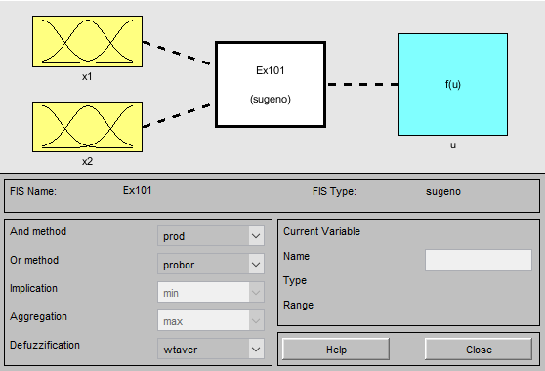
Figure 10.1: The model of the controller for h_{x1} = 0.5 and h_{x2} = 0.5

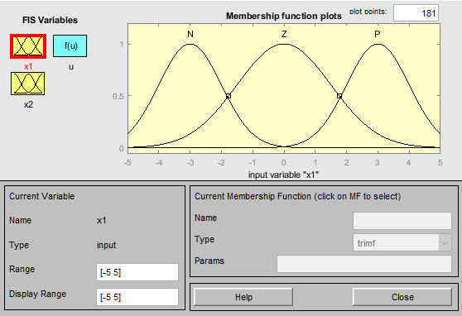
Figure 10.2: The input x1 Gaussian membership functions (a1)

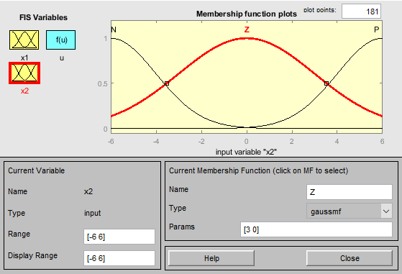
Figure 10.3: The input x2 Gaussian membership functions (a1)

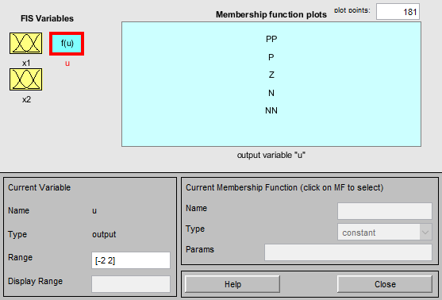
Figure 10.4: The output membership functions (a1)

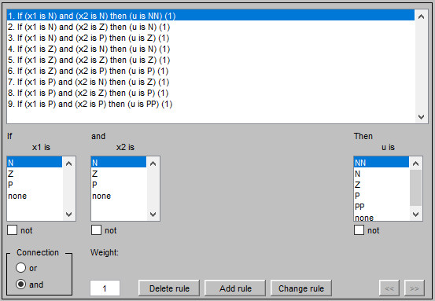
Figure 10.5: The rule base (a1)

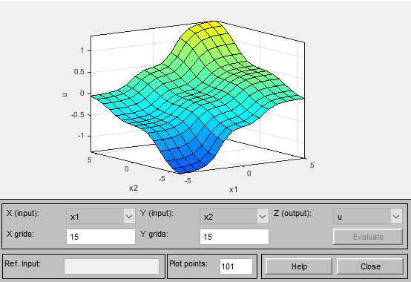
Figure 10.6: The characteristics of the controller (a1)

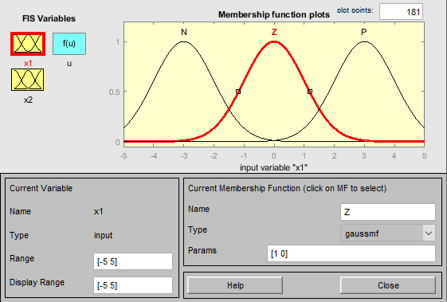
Figure 10.7: The input x1 Gaussian membership functions (a2)

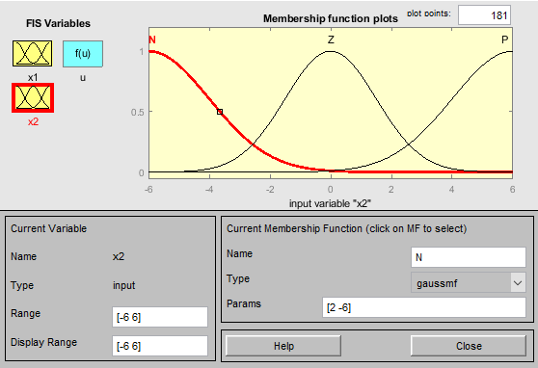
Figure 10.8: The input x2 Gaussian membership functions (a2)

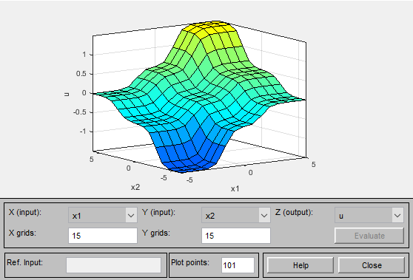
Figure 10.9: The characteristics of the controller (a2)

